Wake up call process

- At the beginning of your shift, get the wake up call report from CA

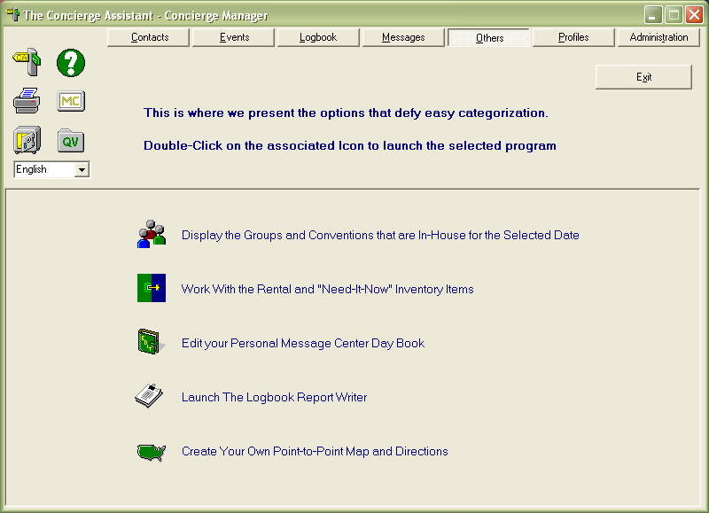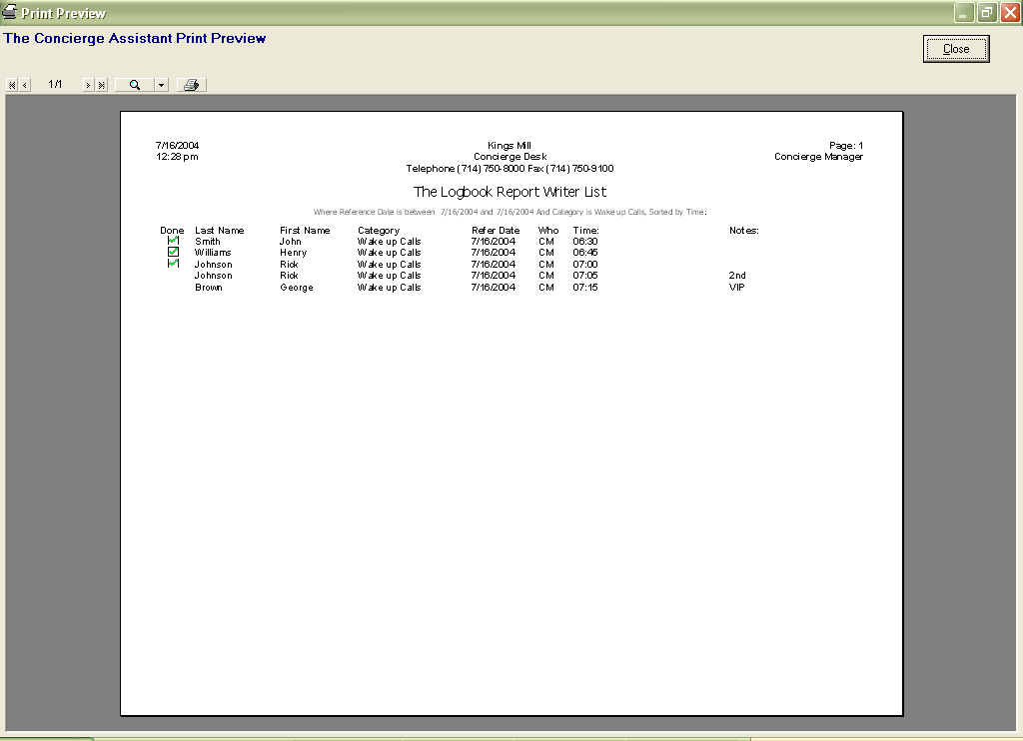

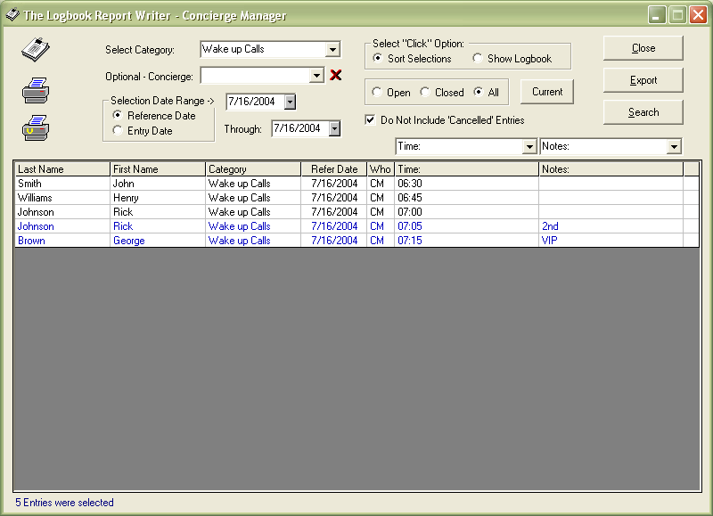

Click the gray area “Time:” to sort the entries by time before your print the report.

- Hit the “due and overdue” button from the logbook screen.

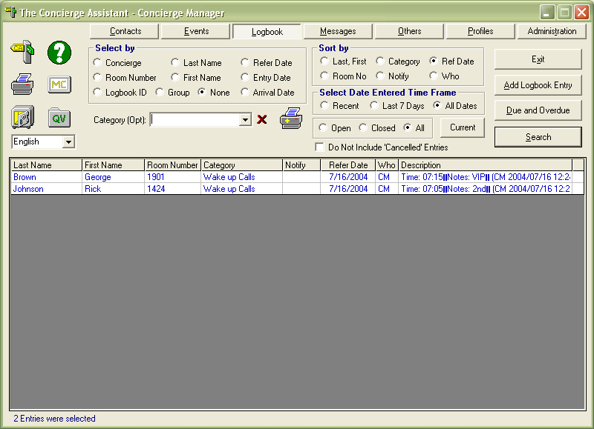

- Receive wake up call request from Guest
- Log wake up call in Concierge Assistant (logbook)

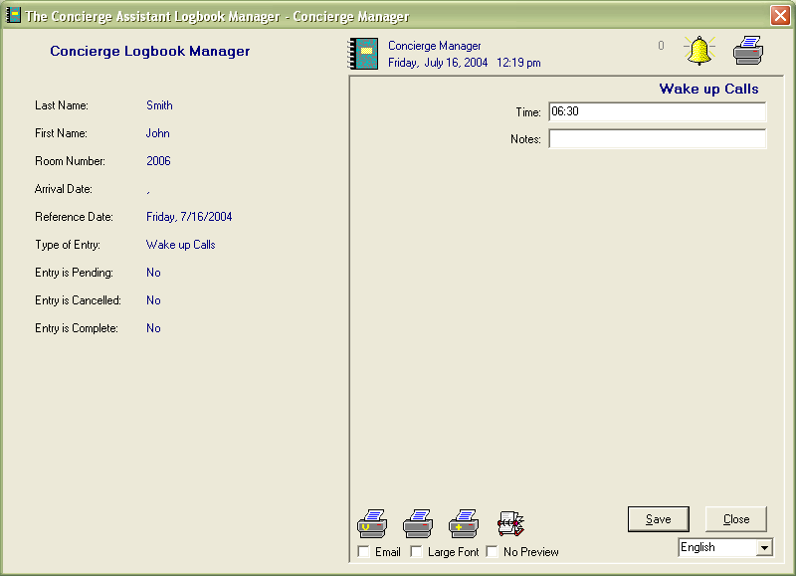
- Input the request in the telephone system
- Mark wake up call as completed in CA

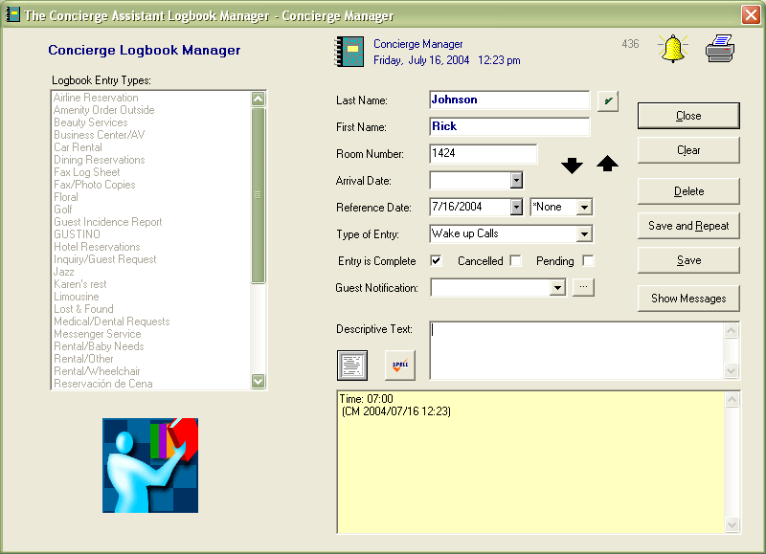

- If a second or VIP wake up call is needed, another entry will be required and we will leave this entry as pending (blue).

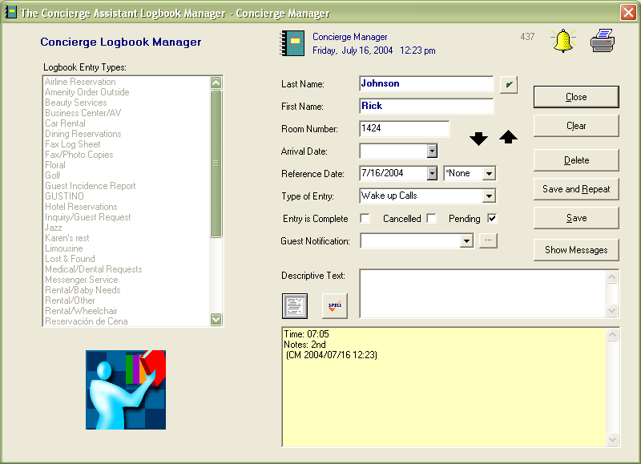

- Before leaving, print wake up call report for the next day.
- As second and VIP wake up calls are completed, mark them as completed in CA (black).

